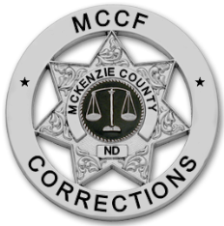
1201 12th st se

Telephone: 701-842-2565

Robert Werlinger, Administrator
MCKENZIE COUNTY CORRECTIONAL FACILITY
suite c
watford city, nd 58854
Fax: 701-842-3529

Inmate Allegations Against Staff
Sexual Abuse- Substantiated | 0
Sexual Abuse- Unsubstantiated | 0
Sexual Abuse- Unfounded | 0
Sexual Harassment- Substantiated | 0
Sexual Harassment- Unsubstantiated | 2
Sexual Harassment- Unfounded | 0
McKenzie County Correctional Facility PREA Data- 2023

Inmate Allegations Against Inmates
Sexual Abuse- Substantiated | 0
Sexual Abuse- Unsubstantiated | 0
Sexual Abuse- Unfounded | 0
Sexual Harassment- Substantiated | 1
Sexual Harassment- Unsubstantiated | 0
Sexual Harassment- Unfounded | 0

